Vulture Necropsy and Sampling Protocol
Approved by SAVE
Prepared by Simon Spiro, Zoological Society of London, March 2020 – Posted with permission by SAVE in February 2026 with supporting information from Andrew Routh. Incorporating material from J. Lindsay Oaks and Melissa Nollet.

An important note on health and safety.

The bottom line is that something killed the vulture. It could kill you. Toxins and zoonotic diseases must be factored in. For the latter, of greatest, current (2026) concern is Highly Pathogenic Avian Influenza. Examination of birds (wild or captive) that have been found dead without signs should be carried out in a biosecure facility. This should be with appropriate PPE, air handling and decontamination to prevent human infection or spread of disease. (It is recognised that these facilities may not always be available). NB: Local legislation may over-rule and dictate how and where a post mortem examination may be performed, carcass retention and disposal.

1) All post mortem examinations (necropsies or PMEs) should be carried out in a comprehensive and systematic manner. (This is equally true whether the cause of death is unknown or if one is suspected e.g. a bird found dead under powerlines may have been electrocuted but other diseases may have led to it being debilitated and landing on the powerlines).

The reasons for a systematic approach are twofold.

- Firstly, following a protocol ensures a comprehensive examination. It results in all organ systems being checked and a full suite of diagnostic samples being taken.

- Secondly, following a standard protocol allows for a dataset to be built up time that can be utilised within an institution over time, between institutions, between species and across countries. The more robust the data the better these findings can be used to inform conservation measures and promote changes in legislation.

2) Lesions should be described (e.g. the lungs are diffusely dark red, firm and sink in formalin) not interpreted ("pneumonia") to allow other professionals to review findings and propose alternative interpretations.

3) Photos should be taken but are not a substitute for good descriptions. Photos should be taken first at distance, to show the whole animal, then in close up, with a ruler in shot for scale. Check each photo before proceeding further. A photo that is blurred or without context must be re-taken. Several photos can be taken and reviewed later, with poor photos discarded.

4) Correct sampling, storage and archiving of tissues is essential. This allows for later review, especially if new diagnostic techniques become available and/or additional funding is found for further investigation. Samples of tissue should be stored in formalin for histopathology (thin sections, at least 10x formalin to tissue) and frozen for virology or toxicology, as well as swabs taken for bacteriology. Swabs should be taken in a sterile manner. Toxicology requires large quantities of organs (~10-20 g). These are best stored in clean glass jars or, if unavailable, wrapped in aluminium foil and then placed in plastic bags and frozen. This is to avoid contamination of the tissue by organic compounds in plastics.

Basic background data
Tag number |  | Date of PM
Species |  | Date of death
Sex |  | Death-PM interval
Age |  | Death Location
Weight (kg) |  | PM Location
Body condition |  | Necropsy by
Wild/captive/  released |  | Period in the wild
Pathologist |  | In attendance
Carcass: fresh/ refrigerated/  frozen |  | Carcass condition:

Morphometric measurements (mm)
Beak |  | Wingspan
Metatarsus |  | Carpus – wing tip
Body length (beak-tip to vent) |  | Body length (head to tail)

History – include recent treatments and blood work (if any)

External Examination

System | Parameters | Description if abnormal, NA if normal, NE if not examined
Body condition | Keel very poor/poor/ fair/good/very good  (prominent keel through to well- muscled)
Feather condition | Moulting, normal, ragged, stress marks
Skin and preen gland | Bruising, other injuries
Beak | Normal size and shape, tearing
Cere | Normal colour, growths, injuries
Feet/Talons | Normal size and shape, injuries, growths, joint swellings
Joints | Normal size and shape, injuries, growths, joint swellings
Limbs | Palpate for fractures
Muscles | Keel, legs, wings: evaluate for symmetry
Eyes | Dry or discharge(s), colour changes (lens or cornea?)
Nares | Dry or discharge(s)
Mouth | Growths, swellings, reddening
Anus/cloaca | Faecal material on vent feathers (pasting)
Parasites | Lice, ticks, mites, fleas
General comments not covered by the above:

Internal Examination

Subcutis
Make a skin incision from the larynx to the cloaca and skin the animal. Disarticulate the hip joints then extend your incision dorsally around the body to also skin the back and the crown of the head. Examine the subcutis thoroughly for bruising (shows up as gelatinous masses of black tissue beneath the skin) or wounds. Pre-mortem wounds can be distinguished from post-mortem wounds by reddening of the edges; if in doubt, save a section of the skin, including the edge of the wound, in formalin for histopathology. Also look for colour changes (e.g. yellow indicates icterus) and assess the amount of subcutaneous fat.

Subcutaneous fat? ☐

Body cavity
Make an incision from the xiphisternum to the cloaca and then two further incisions in the body wall caudal to the last rib to open the coelom. Note and measure any fluids present and examine the air sacs. Remove the pectoral muscles then use shears to cut the ribs and shoulders and remove the keel. Examine all organs in situ and look at the relationship between them (e.g. adhesions, perforations, enlarged organs etc.)

Coelomic fat? ☐

Coelomic cavity:

Gastrointestinal tract and spleen
Cut the vena cava between the liver and the heart and then cut the proventriculus as near the oesophagus as possible. Pull the proventriculus caudally to remove the GI tract, liver and spleen all together; straighten out the intestines then cut them off at the rectum. Inspect each organ individually, describe and sample.
Open the whole gut tube and comment on content (amount, nature):

Crop content:
Proventriculus content:
Gizzard content:
Small intestinal content:
Large intestine content:

Mouth:

Oesophagus and crop:

Proventriculus and gizzard:

Small intestine:

Large intestine and cloaca:

Pancreas:

Liver and gall bladder:

Spleen:

Cardio-respiratory system
Examine the trachea from the mouth to the lungs, looking for foreign bodies. Find and remove the thyroid glands and then, remove the heart before gently scraping the lungs from the body wall. Examine and then bread-slice the lungs to look for internal lesions. Remove the pericardial sac from the heart and examine the epicardium. Dissect the heart, examining all four chambers and all four sets of valves, then cut into the myocardium to look to see if lesions track into the muscle. Open the aorta as far as you can trace it to examine its internal surfaces.

Nose and paranasal sinuses:

Choana:

Trachea, syrinx & bronchi:

Lungs:

Airsacs:

Heart:

Pericardial fat? ☐
Pericardial sac and epicardium:

Right atrium, right ventricle, tricuspid valve and pulmonary valve:

Left atrium, left ventricle, mitral valve and aortic valve:

Aorta:

Urogenital system and adrenal glands
Examine the kidneys, ureters, adrenals and gonad(s) in situ then remove. “Bread slice” the kidneys and bisect the other organs to examine the internal surfaces.

Kidneys:

Ureters:

Gonad (+/-oviduct):

Adrenal gland:

Nervous system
Examine the sciatic nerves where they pass through the kidneys and in the hindlimbs. Remove the crown of the skull and examine the brain in situ, then gently remove by cutting the cranial nerves and olfactory lobe. Examine and remove both eyes. Eyes and brain should be fixed whole, without dissection.

Peripheral nerves including sciatic nerve:

Brain (cerebrum & cerebellum):

Spinal cord:

Middle ear:

Eyes ex-situ:

Musculoskeletal system
Muscles:

Bones:

Joints:

Miscellaneous (e.g. bursa of Fabricius, thymus, thyroid etc.):

Sampling
The following tissues must be taken as a minimum:
 | Formalin-fixed | Frozen
Heart blood |  | ☐
Lung | ☐
Liver | ☐ | ☐
Heart | ☐
Kidney | ☐ | ☐
Spleen | ☐
Brain (half frozen, half fixed) | ☐ | ☐
Stomach content |  | ☐
Proventriculus | ☐
Small intestine | ☐
Large intestine | ☐
Fat |  | ☐
Additional tissues – list below
Rectal faeces for microbiology and faecal egg count: ☐
Cytological smear of heart blood for haemoparasites: ☐
Tissues for toxicology: ☐ Liver x 2: ☐ Kidney x 2: ☐
Swabs of liver, heart blood and any organ that looks diseased (list which) and tests requested:
☐ Liver ☐Heart blood ☐……………………………..
☐…………………………….. ☐…………………………….. ☐……………………………..
Parasites into ethanol:
☐ …………………………….. ☐…………………………….. ☐……………………………..
☐…………………………….. ☐…………………………….. ☐……………………………..
Additionally, any tissue with a lesion in it should be sampled into formalin and potentially frozen. It is always preferable to store too much than too little. List additional tissues below:

Summary of lesions and comment at gross post mortem examination. Interim diagnosis and sign off – name and date:
Gross post mortem examination complete – date and initial:

Draft write-up completed – date and initial:

Tissues (including carcass) archived and where – date and initial:

Samples and tissues processed internally – date and initial:

Samples and tissues dispatched externally and where – date and initial:

Internal results received and written up – date and initial:

External results received and written up – date and initial:

Actions to be taken - date and initial:

Concluding remarks, diagnosis and sign-off – name and date:

NB:
- Post-mortem examinations must be carried out within 24 hours of animal’s deaths, wherever possible
- The following tissues must be stored from every post-mortem: lung, liver, heart, kidney, spleen, brain, pancreas, proventriculus and gizzard, trachea, small intestine and large intestine, plus any tissue that contains a lesion.
- Tissues should be cut to no more than 5 mm thick and be stored in 10x their own volume of formalin
- All samples for virology should ideally be stored and kept frozen
- Samples for DNA – can be kept frozen and/or on FD cards (FTA cards)

Organ weights

Organ | Weight (g) | Comments
Liver
Heart
Spleen
Kidney R
Kidney L
Lung R
Lung L
Others – insert as appropriate

Internal organs of a vulture
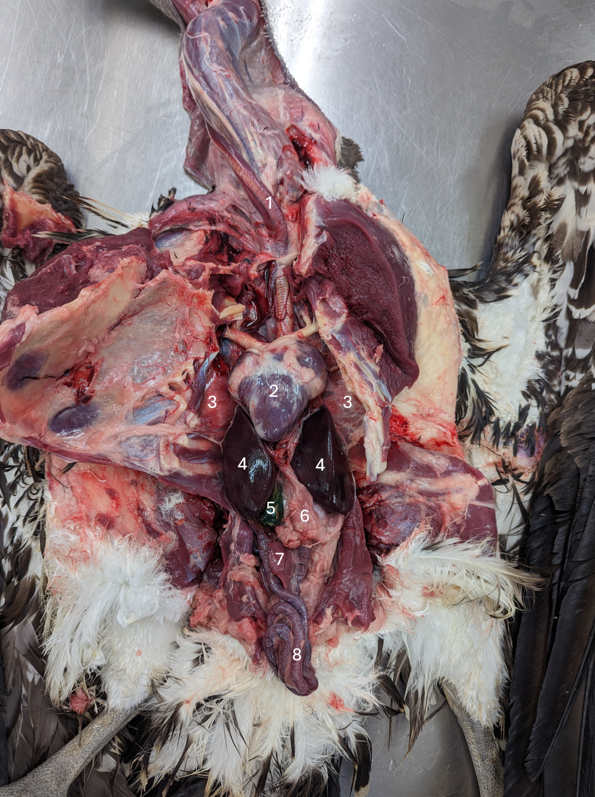
- Trachea
- Heart
- Lung
- Liver
- Gall bladder
- Gizzard
- Pancreas
- Small intestine

